**The White House, United States of America**

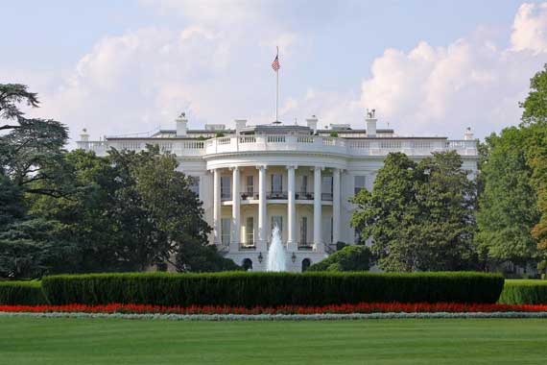

Built between 1792 and 1800 and designed by Irish-born James Habon, White House is the official residence and main work place of the President of the United States of America. The White House stands for the power and democracy of United States and it has become one of the biggest representative monument of the country and the world.